# WORKSHEET



**STATISTICS WORKSHEET-1**

**Q1 to Q9 have only one correct answer. Choose the correct option to answer your question.**

1. Bernoulli random variables take (only) the values 1 and 0. a) True

b) False

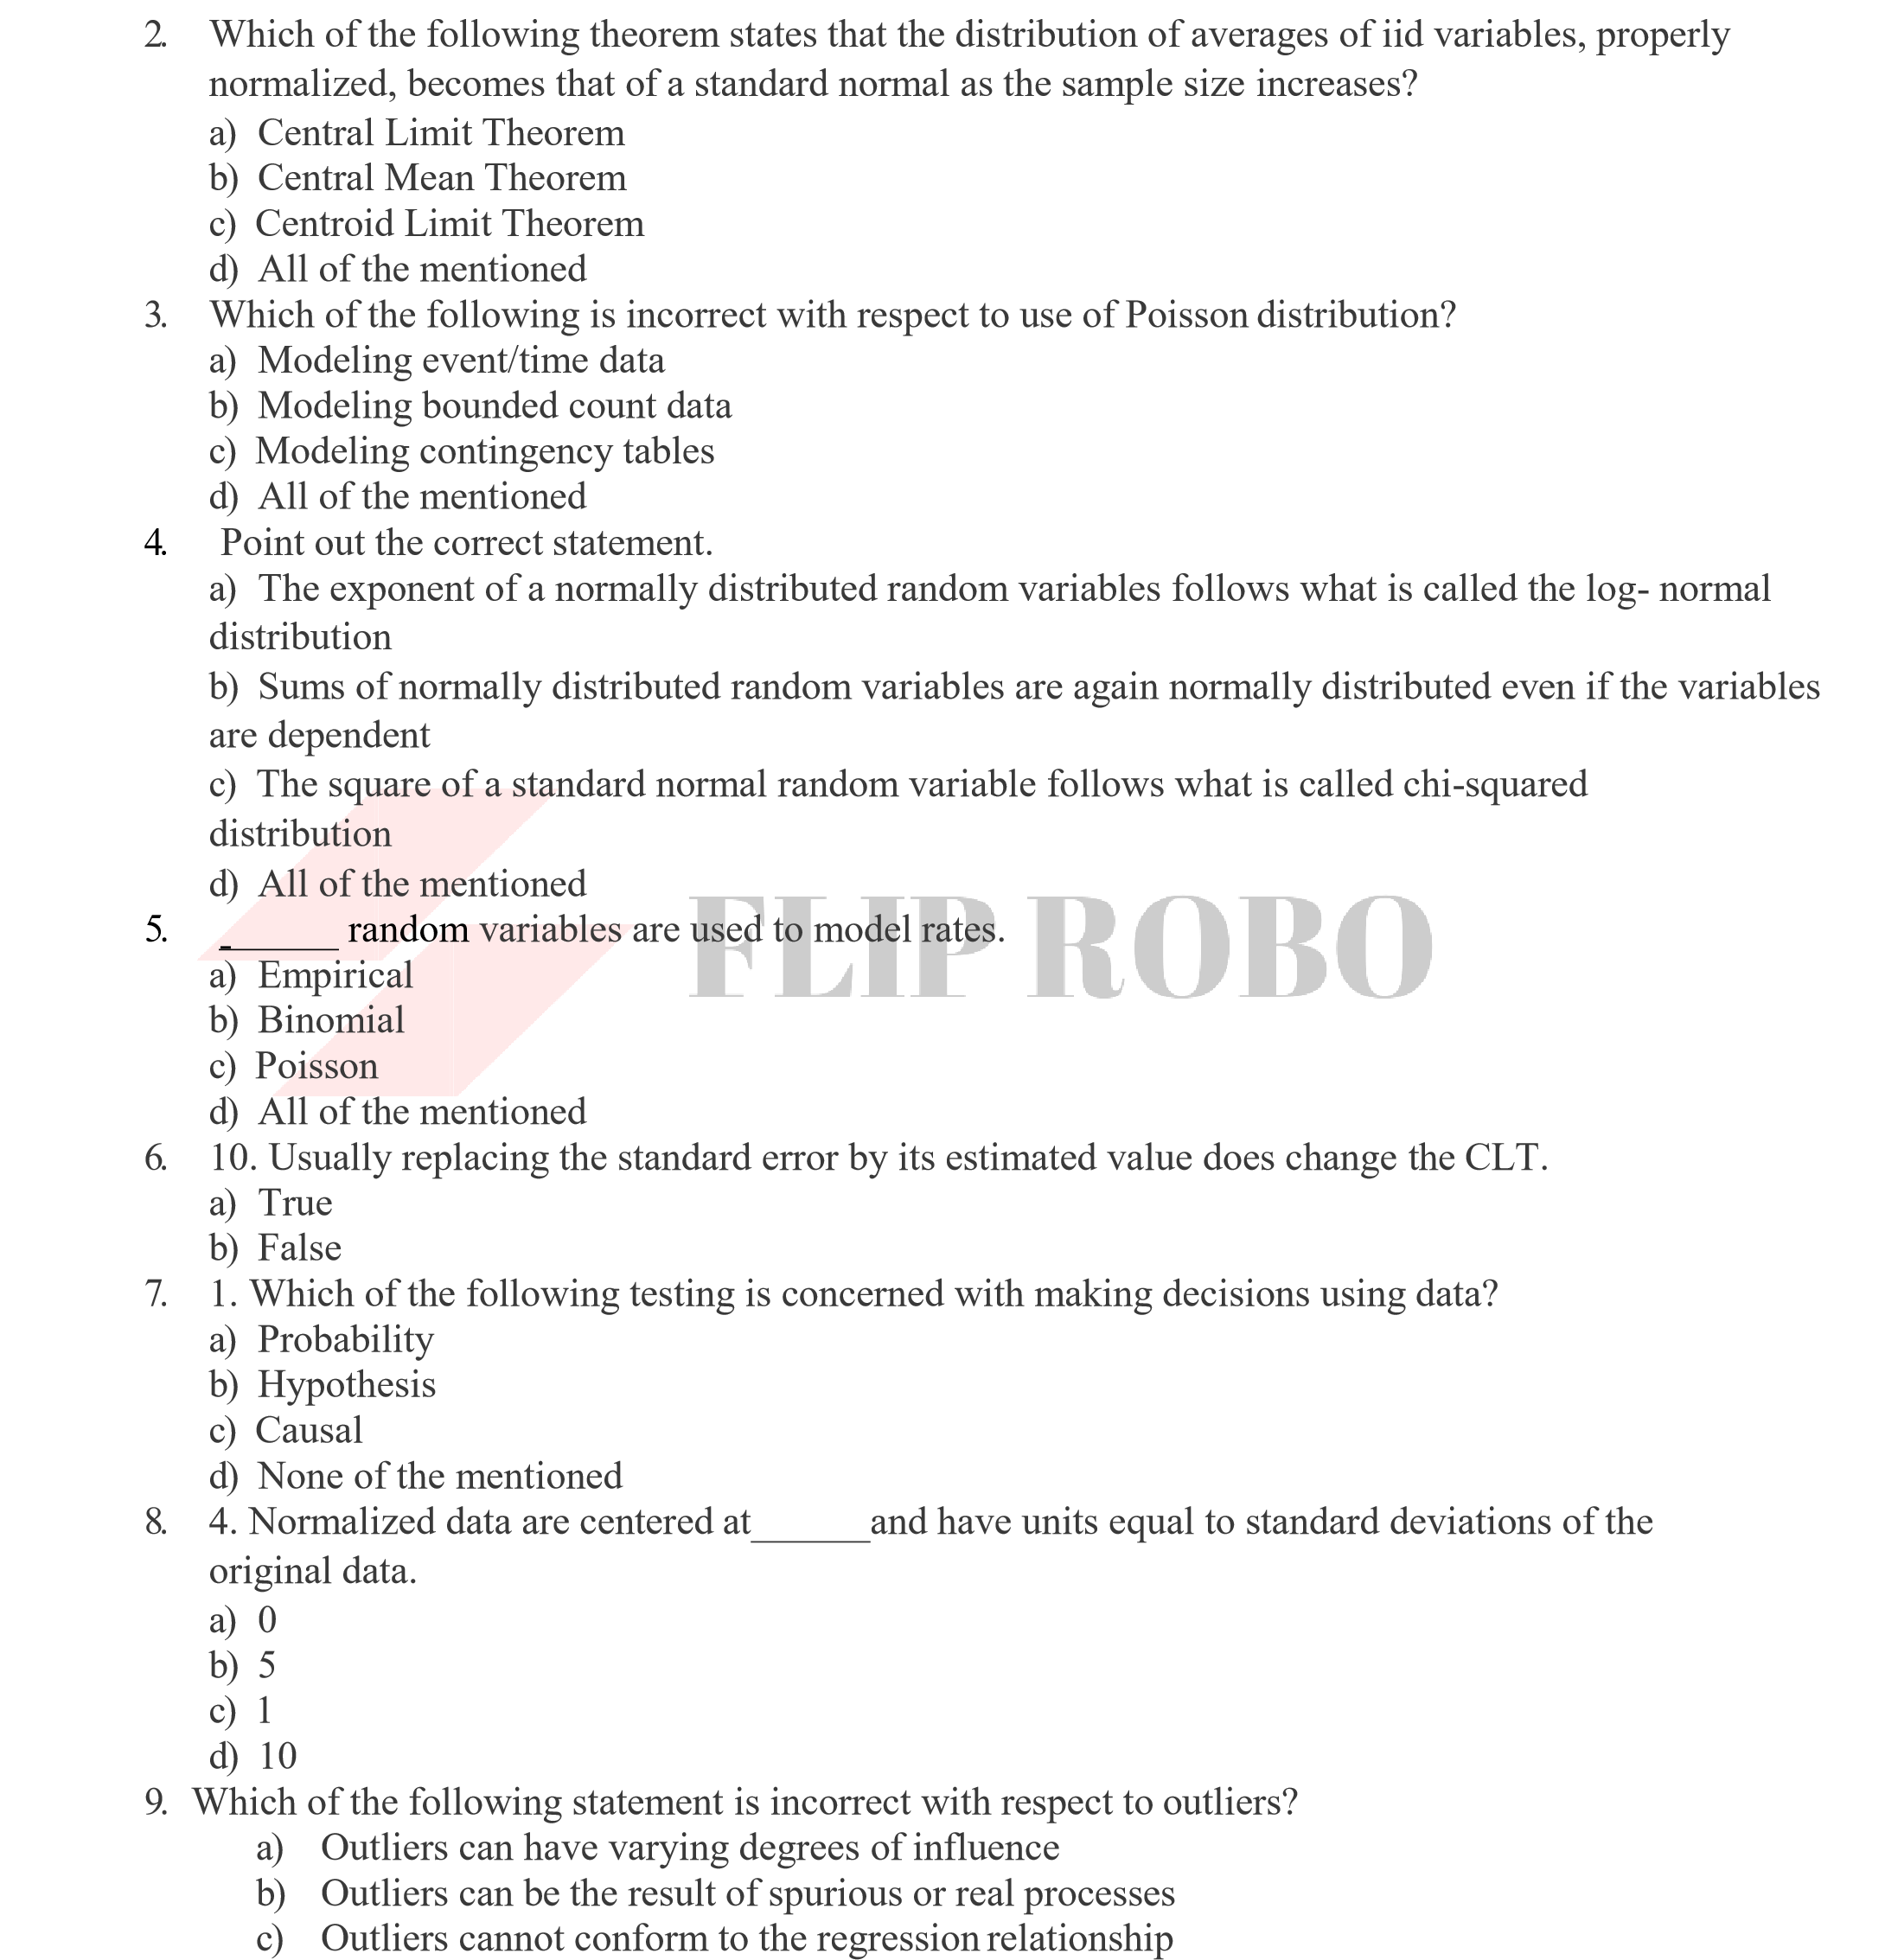

d) None of the mentioned

# WORKSHEET



**Q10and Q15 are subjective answer type questions, Answer them in your own words briefly.**

1. What do you understand by the term Normal Distribution?
2. How do you handle missing data? What imputation techniques do you recommend?
3. What is A/B testing?
4. Is mean imputation of missing data acceptable practice?
5. What is linear regression in statistics?

15. What are the various branches of statistics?

